+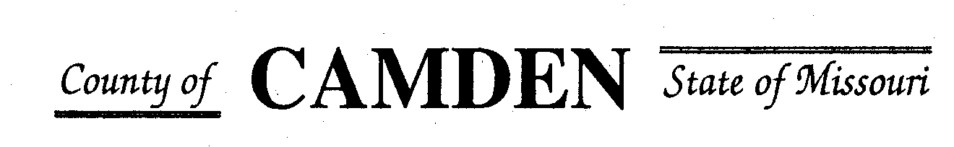

**SENIOR CITIZENS’ SERVICES FUND BOARD**

**Agenda**

**PLACE: Camden County Court House**

**DATE:  July 20, 2023 TIME: 1:00 pm**

* **CALL TO ORDER /Pledge**
* **ROLL CALL – Board Members ~**
* **ROLL CALL OF ATTENDEES~** *Signature sheet, must sign in*
* **ADOPTION OF AGENDA.**
* **APPROVAL OF PREVIOUS MINUTES ~**
* **TREASURER’S REPORTS previous bal $** Funds Available $
  + - **Checks Received**  **2023 Camden County Tax Funds Received**
    - January $581,656.03 verified against bank statement
    - February $36,011.41
    - March $11,981.12
    - April $10,584.99
    - May $6,158.23
    - June
    - July
    - Aug
    - Sept
    - October
    - November
    - December
    - All checks electronically deposited are verified by placing verified next to the amount
  1. **Outstanding Checks** See treasurer report.
* **OLD BUSINESS**

1. **Accountability Reports due 7/15/23 only have received a few of these.**

**NEW BUSINESS**

* + - 1. **MoAlso Membership** We have not seen much benefit from this membership do we want to continue or not. Renewal is due.
      2. **Disburse Funds Approved for 2023 Grants**.

* **STATEMENTS FROM THE PUBLIC (Limited to 3 minutes per Agency or attendee with a maximum of 20 minutes total.)**
* **Motion to Adjourn** 2:49 Passed

**NEXT MEETING:** September 21, 2023 @ 1pm Camden County Court House

**REMINDER**

* + 1. **Website**: <https://camdencountyseniorservicesfund.com/> to complete RFP for 2022. For all information Regarding Camden County Senior Services Fund.
    2. **New Secretary email:** [CamdensrBoardSEC@outlook.com](mailto:CamdensrBoardSEC@outlook.com)