+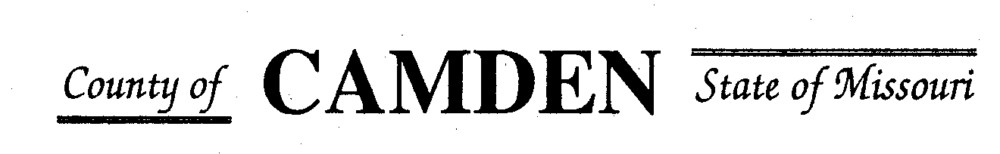

**SENIOR CITIZENS’ SERVICES FUND BOARD**

**Meeting Minuetes**

**PLACE: At Mid Co Fire District 184 N Business Rt 5, Camdenton, Mo 65020**

**DATE:  February 16, 2023 TIME: 1:00 pm**

* **CALL TO ORDER /Pledge**
* **ROLL CALL – Board Members ~Jim Rogers, Marie Brown, David Curchy, Janel Bednara, Carolyn Davinroy, Stephanie Krehbiel all present**
* **ROLL CALL OF ATTENDEES~** *Signature sheet, must sign in*
* **ADOPTION OF AGENDA.**  Motion and Approved
* **APPROVAL OF PREVIOUS MINUTES ~Motion and** Approved
* **TREASURER’S REPORTS previous bal $662,701.08** Funds Available $1,240,305.48
  + - **Checks Received**  **2023 Camden County Tax Funds Received**
    - January $581,656.03 verified against bank statement
    - February
    - March
    - April
    - May
    - June
    - July
    - Aug
    - Sept
    - October
    - November
    - December
    - All checks electronically deposited are verified by placing verified next to the amount
  1. **Outstanding Checks** See treasurer report.
* **OLD BUSINESS**

1. **RFP’s received reviews**
   1. West Side Senior Center RFP Request for funding Motion passed and approved
   2. West Lakes Aquatic Center motion to fund and get operating report in next 10 days.
   3. Senior Activity Center Motion to Approve
2. **Motion to add Total Operating Budget to RFP’s for 2024.** Motion passed and Approved.

**NEW BUSINESS**

* + - 1. **Disburse Funds Approved for 2023 Grants** Motion and passed All distributed except Camden County Health and Four Seasons not disbursed no representative present. Contracts will need signed prior to disbursement. Secretary to email with directions.
      2. **Increase Reserve Funds for Board Expenses** Motion to increase Passed Policy and Procedures changes for second vote passed. Policy to be amended and placed on website.
      3. **Bank Account interest rate** Approved to seek LPL Financial and/or Oakstar Bank and/or Edward Jones and any other bank for fund deposits for higher yield interest between disbursements. Any fund movement must be signed off by Board Chairman and Board Treasurer. All board members are in agreement to find the best interest rate to hold funds.
      4. **Accountability Reports Due 1/15/2023** ~ Outstanding reports still needed: Secretary to send out email to entities needing year end budget reports submitted and Quarterly reports. No vote needed.
      5. **Review of Policy and Procedure changes** to be added from board Approved measures for 2022 /Depository section of policy Motion to change 2nd vote passed.

* **STATEMENTS FROM THE PUBLIC (Limited to 3 minutes per Agency or attendee with a maximum of 20 minutes total.)**
* **Motion to Adjourn** 2:49 Passed

**NEXT MEETING:** July 20 @ 1pm Camden County Court House

**REMINDER**

* + 1. **Website**: <https://camdencountyseniorservicesfund.com/> to complete RFP for 2022. For all information Regarding Camden County Senior Services Fund.
    2. **New Secretary email:** [CamdensrBoardSEC@outlook.com](mailto:CamdensrBoardSEC@outlook.com)