+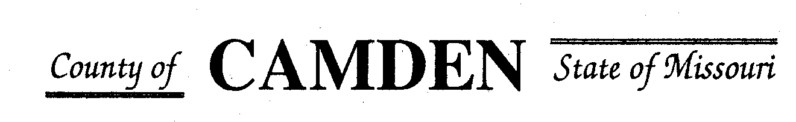

**SENIOR CITIZENS’ SERVICES FUND BOARD**

**Meeting Minutes**

**PLACE: Camden County Court House**

**DATE:  July 20, 2023 TIME: 1:00 pm**

* **CALL TO ORDER /Pledge**
* **ROLL CALL – Board Members ~** Jim Rogers, Marie Brown, David Curchy, James Powel present until after vote for Approval to disburse second installment of RFP to Guarantees. Janell Bednara, Carolyn Davinroy, Stephanie Krehbiel
* **ROLL CALL OF ATTENDEES~** *Signature sheet, must sign in*
* **ADOPTION OF AGENDA.**  Approved unanimously
* **APPROVAL OF PREVIOUS MINUTES ~**
* **TREASURER’S checking previous bal $ 486,591.87 CD $410,000.00 August 18th mature** Funds Available $896,591.87
  + - **Checks Received**  **2023 Camden County Tax Funds Received**
    - January $581,656.03 verified against bank statement
    - February $36,011.41 verified
    - March $11,981.12 verified
    - April $10,584.99 verified
    - May $6,158.23 verified
    - June
    - July
    - Aug
    - Sept
    - October
    - November
    - December
    - All checks electronically deposited are verified by placing verified next to the amount
  1. **Outstanding Checks** See treasurer report. $145 State of Mo re-instate back with state to deposit funds in other institutions for higher interest rate.

Approved unanimously by all board members.

* **OLD BUSINESS**

1. **Accountability Reports due 7/15/23 only have received a few of these. These need returned ASAP as they were due 7/15/23.**

**NEW BUSINESS**

* + - 1. **MoAlso Membership** We have not seen much benefit from this membership do we want to continue or not. Renewal is due. Board voted to decline renewal at this time. Motion passed all approved except Jim Powell Absent.
      2. **Disburse Funds Approved for 2023 Grants**. All Remaining Funds were needed. Share the Harvest decreased funds by $1.00 per their request. Motion passed by all 7 board members.
      3. **CD Withdrawl amount for maturity**. Board identified that at this time there was no need to withdraw funds from the CD and the CD could be renewed through February 2024. Motion passed and Approved by all except Jim Powell not present.
      4. **Westlakes Boiler Repair was covered by Insurance** Motion to require Westlakes to return the $3500.00 that was covered by insurance for the repair. Motion passed. Westlakes to mail check to Treasurer for deposit.

* **STATEMENTS FROM THE PUBLIC (Limited to 3 minutes per Agency or attendee with a maximum of 20 minutes total.)**
  + Several entities have identified they are in need of additional funding in September. All entities will need to get the information and request to the treasured by Sept 6, 2023 to be considered for additional funds. Total amount of expected request is around $18,500.00
    - Stoutland, Oats, Senior Activity Center, Medical Missions for Christ
* **Motion to Adjourn** 2:15 Passed

**NEXT MEETING:** September 21, 2023 @ 1pm Camden County Court House

**REMINDER**

* + 1. **Website**: <https://camdencountyseniorservicesfund.com/> to complete RFP for 2022. For all information Regarding Camden County Senior Services Fund.
    2. **New Secretary email:** [CamdensrBoardSEC@outlook.com](mailto:CamdensrBoardSEC@outlook.com)