+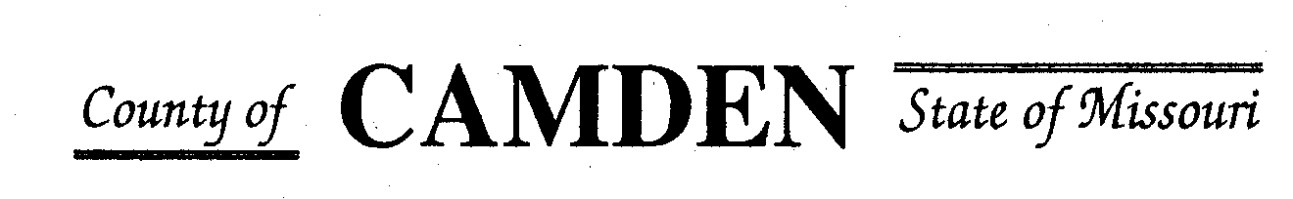

**SENIOR CITIZENS’ SERVICES FUND BOARD**

**Meeting Minutes**

**PLACE: Camden County Court House**

**DATE:  September 21, 2023 TIME: 1:00 pm**

* **CALL TO ORDER /Pledge**
* **ROLL CALL – Board Members ~Jim Rogers, James Powell, Carolyn Daviroy, Marie Brwons, Stephanie Krehbiel, Janel Bednara Absent David Curchy**
* **ROLL CALL OF ATTENDEES~** *Signature sheet, must sign in*
* **ADOPTION OF AGENDA.**  Public Statements first each month passed.
* **APPROVAL OF PREVIOUS MINUTES ~** Motion to approve meeting minutes.
* **TREASURER’S REPORTS previous bal $** Funds Available $
  + - **Checks Received**  **2023 Camden County Tax Funds Received**
    - January $581,656.03 verified against bank statement
    - February $36,011.41
    - March $11,981.12
    - April $10,584.99
    - May $6,158.23
    - June $5727.97
    - July $4647.20
    - Aug $4480.20
    - Sept
    - October
    - November
    - December
    - All checks electronically deposited are verified by placing verified next to the amount

*ADDEndum to Meeting minutes: Kendra’s Treasurer Report was incorrect. Meeting minutes amended to reflect correct Deposit amounts received.for June $5345.05, July $5727.97 and August $4648.20. The $15K on treasurer report was from CD deposit interest and transfer into account from CD rollover.*

* 1. **Outstanding Checks** See treasurer report.
     + **$3500 return by Westlakes Tabled Approval clarification on funds and Westlakes return CADCV $9k discrepancy**
* **OLD BUSINESS**

1. **Accountability Reports due 10/15/23**

**NEW BUSINESS**

1. **Additional Funding Requests**
   1. **Stoutland $3120.00 Approved**
   2. **Oats $7500 Approved**
   3. **Macks Creek** Funds for Table up to table $6500.00 Approved with Receipt
   4. **CADV $5000.00 Approved**
   5. **Medical Mission $3500 Approved**
   6. **Four Seasons $10,000 Approved**

* **STATEMENTS FROM THE PUBLIC (Limited to 3 minutes per Agency or attendee with a maximum of 20 minutes total.)**
  + Heal center Lunch an learn noon to 1pm also on face book live Elizabeth Barret LAC. Next one is Oct 20th. Cover different topics related to health eastern medicine. Hormonal balance tomorrow**. Flyers, Website and Facebook to notify the community. Food in Laurie. 304 North mainstreet laurie**
  + Mike Key Richland Sr Service. Starting to see increase in price with the same amount of people but it’s costing 15% more.
* **Motion to Adjourn**  2:00pm Approved

**NEXT MEETING:** October 19, 2023 @ 1pm Camden County Court House

**REMINDER**

* + 1. **Website**: <https://camdencountyseniorservicesfund.com/> to complete RFP for 2022. For all information Regarding Camden County Senior Services Fund.
    2. **New Secretary email:** [CamdensrBoardSEC@outlook.com](mailto:CamdensrBoardSEC@outlook.com)