+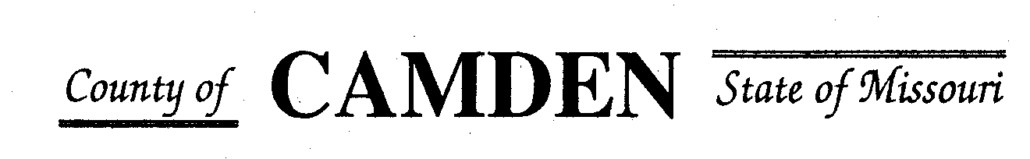

**SENIOR CITIZENS’ SERVICES FUND BOARD**

**Agenda**

**PLACE: Camden County Court House**

**DATE:  November 16, 2023 TIME: 1:00 pm**

* **CALL TO ORDER Cell Phones on silent or turned off Please /Pledge**
* **ROLL CALL – Board Members ~**
* **ROLL CALL OF ATTENDEES~** *Signature sheet, must sign in*
* **STATEMENTS FROM THE PUBLIC (Limited to 3 minutes per Agency or attendee with a maximum of 20 minutes total.)**
* **Board Meeting closed to public comments**
* **ADOPTION OF AGENDA. Approved**
* **APPROVAL OF PREVIOUS MINUTES ~**
* **TREASURER’S REPORTS previous bal $ $400,000 CD Matures in Jan** Funds Available $
  + - **Checks Received**  **2023 Camden County Tax Funds Received**
    - January $581,656.03 verified against bank statement
    - February $36,011.41 verified against bank statement
    - March $11,981.12 verified against bank statement April $10,584.99
    - May $6,158.23 verified against bank statement
    - June $5727.97 needs confirmed amounts off from Treasurer report to deposit
    - July $4648.20 confirmed amounts off from Treasurer report to deposit
    - Aug $4480.20 verified needs against bank statement $15,123.81 verified to deposit
    - Sept $4480.20 Verified against bank statement
    - October $2900.74
    - November
    - December
    - All checks electronically deposited are verified by placing verified next to the amount
  1. **Outstanding Checks Issued another check to Four Seasons placed stop hold**
* **OLD BUSINESS**
  + 1. Follow up from Jeff Greene and insurance update to board members

**NEW BUSINESS**

1. Website update for 2024 Coldwell Communications (Michael)~ We will have .gov domain however can not get due to Federal site manager is down through Jan who issue these changes next year, we will change . Cost of new website development: We will be able to make updates and changes vs relying on someone else.
2. RFP review and questions to applicants only no side conversations please.

**NEXT MEETING:** December 14, 2023 @ 1pm Camden County Court House

**REMINDER Website**: <https://camdencountyseniorservicesfund.com/> to complete RFP for 2024. For all information Regarding Camden County Senior Services Fund. **Secretary email:** [CamdensrBoardSEC@outlook.com](mailto:CamdensrBoardSEC@outlook.com)