+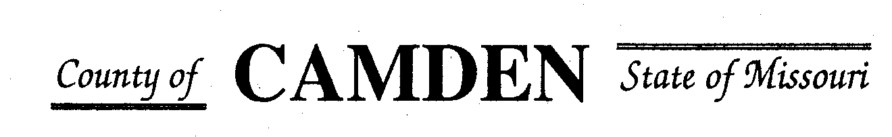

**SENIOR CITIZENS’ SERVICES FUND BOARD**

**Agenda**

**PLACE: Camden County Court House**

**DATE: February 15, 2024 TIME: 1:00 pm**

* **CALL TO ORDER Cell Phones on silent or turned off Please /Pledge**
* **ROLL CALL – Board Members ~**
* **ROLL CALL OF ATTENDEES~** *Signature sheet, must sign in*
* **STATEMENTS FROM THE PUBLIC (Limited to 3 minutes per Agency or attendee with a maximum of 20 minutes total.)**

**Board Meeting closed to public comments**

* **ADOPTION OF AGENDA.**
* **APPROVAL OF PREVIOUS MINUTES ~**
* **TREASURER’S REPORTS previous bal $400,000 CD Matures in Jan** Funds Available
  + - **Checks Received**  **2024 Camden County Tax Funds Received**
    - January
    - February
    - March
    - April
    - May
    - June
    - July
    - August
    - September
    - October
    - November
    - December
      * **All checks electronically deposited are verified by placing verified next to the amount**
  1. **Outstanding Checks**
* **OLD BUSINESS**
  1. Follow up from Jeff Greene and Bond insurance update to board members, 503c and EIN#
  2. RFP review and questions to applicants only. **No side conversations please.**
  3. West Lakes Aquatics RFP consideration $45,000 requested
* **NEW BUSINESS**
  + Check Disbursements for approved RFP
    - * Warren Senior Center Approved for $13400.00
      * Macks Creek Approved for $83000.00
      * Camden County Health Department Approved $16500 for distribution fund the total amount $33,500.00
      * Westside Fitness Center $24K Monthly Reporting
      * Faith Bridge $6700.00 Monthly Reporting
      * Stoutland $67,000.00 left aging best no funding from Aging Best
      * Macks Creek $83,000.00
      * Share the Harvest Voucher $100,000.00 w/relook July
      * Share the Harvest Food Pantry $60,000.00
      * Oats $75,000.00
      * Osage Beach $85000.00
      * Heal Center $15,500.00
      * Westside Senior Center $40K
      * Camdenton Senior Center $100,000.
      * Medical Missions $30,000.00 relook July
      * Four Seasons $36,500.00 relook July
      * Senior Activity Center $10,000
      * Heart to Heart Center for Women’s Ministries $1,000.00 with monthly reporting of where funds are used.
      * CADV (Jan) Start Quarterly Reporting $18,000.00

**Motion to Adjourn:**

**NEXT MEETING:** July 18, 2024 @ 1pm Camden County Court House **You or an AUTHORIZED REP MUST BE PRESENT TO PICK UP CHECK OR The Check Will be returned to general fund for disbursement in September.**

**REMINDER Website**: <https://camdencountyseniorservicesfund.com/> to complete RFP for 2024. For all information Regarding Camden County Senior Services Fund. **Secretary email:** [CamdensrBoardSEC@outlook.com](mailto:CamdensrBoardSEC@outlook.com)