+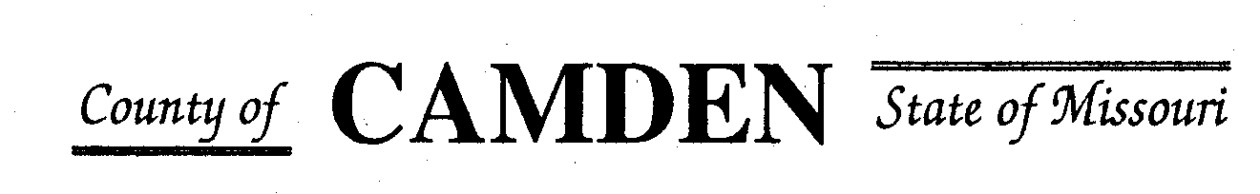

**SENIOR CITIZENS’ SERVICES FUND BOARD**

**Meeting Minutes**

**PLACE: Camden County Court House**

**DATE:  October 19, 2023 TIME: 1:00 pm**

* **CALL TO ORDER /Pledge**
* **ROLL CALL – Board Members ~** Jim Rogers, Carolyn Davinroy, Marie Brown, David Curchy, Stephanie Krehbiel, James Powel, Janel Bednara
* **ROLL CALL OF ATTENDEES~** *Signature sheet, must sign in*
* **ADOPTION OF AGENDA. Approved**
* **APPROVAL OF PREVIOUS MINUTES ~** Approved
* **TREASURER’S REPORTS previous bal $ $400,000 CD Matures in Jan** Funds Available $
  + - **Checks Received**  **2023 Camden County Tax Funds Received**
    - January $581,656.03 verified against bank statement
    - February $36,011.41 verified against bank statement
    - March $11,981.12 verified against bank statement
    - April $10,584.99
    - May $6,158.23 verified against bank statement
    - June $5345.05 needs confirmed amounts off from Treasurer report to deposit Verified
    - July $5727.97 confirmed amounts off from Treasurer report to deposit Verified
    - Aug $4648.20 verified against bank statement $15,123.81 verified to deposit
    - Sept $4480.20 Verified against bank statement
    - October
    - November
    - December
    - All checks electronically deposited are verified by placing verified next to the amount
  1. **Outstanding Checks Issued another check to Four Seasons placed stop hold**
* **OLD BUSINESS**

**NEW BUSINESS**

1. **RFP review and questions to applicants**
2. **Review Insurance through County update?**

* **STATEMENTS FROM THE PUBLIC (Limited to 3 minutes per Agency or attendee with a maximum of 20 minutes total.)**
  + Ben Jacobe YMCAOsage Beach~3600 Members now. Senior Wellness. Member of YMCA any access to any pool. $ to help add classes Parkinsons Disease classes. Over 2K already attended. Classes for seniors boxing class for Parkinson’s $1,000 to get the program. Classes free for members, most are free. Over 60 fee is $23-$24/mo or year for prime.
* **Motion to Adjourn 2:10pm Motion to adjourn approved**

**NEXT MEETING:** November 16, 2023 @ 1pm Camden County Court House

**REMINDER Website**: <https://camdencountyseniorservicesfund.com/> to complete RFP for 2024. For all information Regarding Camden County Senior Services Fund. **Secretary email:** [CamdensrBoardSEC@outlook.com](mailto:CamdensrBoardSEC@outlook.com)