+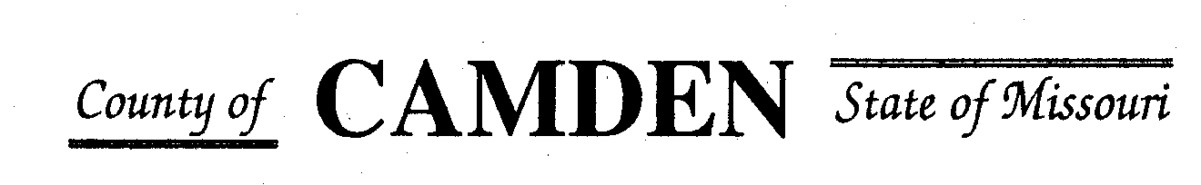

**SENIOR CITIZENS’ SERVICES FUND BOARD**

**Meeting Minutes**

**PLACE: Camden County Court House**

**DATE:  December 14, 2023 TIME: 1:00 pm**

* **CALL TO ORDER Cell Phones on silent or turned off Please /Pledge**
* **ROLL CALL – Board Members ~**
* **ROLL CALL OF ATTENDEES~** *Signature sheet, must sign in*
* **STATEMENTS FROM THE PUBLIC (Limited to 3 minutes per Agency or attendee with a maximum of 20 minutes total.)**

**Board Meeting closed to public comments**

* **ADOPTION OF AGENDA.**
* **APPROVAL OF PREVIOUS MINUTES ~**
* **TREASURER’S REPORTS previous bal $400,000 CD Matures in Jan** Funds Available
  + - **Checks Received**  **2023 Camden County Tax Funds Received**
    - January $581,656.03 verified against bank statement
    - February $36,011.41 verified against bank statement
    - March $11,981.12 verified against bank statement
    - April $10,584.99
    - May $6,158.23 verified against bank statement
    - June $5345.05 onfirmed amounts off from Treasurer report to deposit Verified
    - July $5727.97 confirmed amounts off from Treasurer report to deposit Verified
    - Aug $4648.20 verified against bank statement $15,123.81 verified to deposit
    - Sept $4480.20 Verified against bank statement
    - October $0.00 verified
    - November $2736.22 + $2900.74
    - December

**All checks electronically deposited are verified by placing verified next to the amount**

* 1. **Outstanding Checks**
* **OLD BUSINESS**
  + 1. Follow up from Jeff Greene and insurance update to board members
    2. RFP Funding Approved
       - Warren Senior Center Approved for $13400.00
       - Macks Creek Approved for $83000.00
       - Camden County Health Department Approved $16500 for distribution fund the total amount
* **NEW BUSINESS**
* RFP review and questions to applicants only. **No side conversations please.** We will get through all we have time for and continue the conversations in December and January.
  + Westside Fitness Center $24K
  + Heart to Heart Center for Women’s Ministries no rep again
  + Faith Bridge $6700.00
  + Stoutland $67,000.00 left aging best no funding
  + Warren Senior Center $13,400.00
  + Macks Creek $83,000.00
  + Share the Harvest Voucher $100,000.00 w/relook July
  + Share the Harvest Food Pantry $60,000.00
  + Oats $75,000.00
  + Osage Beach $85000.00
  + Heal Center $15,500.00
  + Camdenton Senior Center $100,000.
  + CADV (Jan)
  + Camden County Health Department $33,500.00
  + West Lakes Aquatics$10,000
  + Westside Senior Center $40K
  + Senior Activity Center
  + Medical Missions $30,000.00 relook July
  + Four Seasons $36,500.00 relook July

**Motion to Adjourn:**

**NEXT MEETING:** January 18, 2024 @ 1pm Camden County Court House

**REMINDER Website**: <https://camdencountyseniorservicesfund.com/> to complete RFP for 2024. For all information Regarding Camden County Senior Services Fund. **Secretary email:** [CamdensrBoardSEC@outlook.com](mailto:CamdensrBoardSEC@outlook.com)