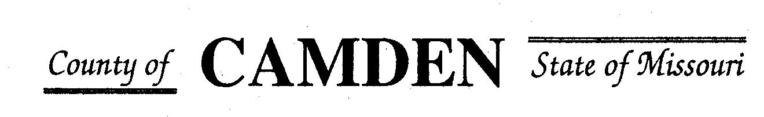

PUBLIC NOTICE

SENIOR CITIZENS’ SERVICES FUND BOARD

MONTHLY MEETING SCHEDULE

1/1/2024 – 12/31/2024

THE CAMDEN COUNTY SENIOR CITIZENS’ SERVICES FUND BOARD WILL MEET AT 1:00 PM ON THE DATES BELOW at the Camden County Court House

January 18,2024 September 19, 2024

February 15,2024 October 17, 2024

March 21, 2024 TBD November 21, 2024

July 18, 2024 December 12, 2024

MEETINGS ARE REGULARLY HELD ON THE 3RD THURSDAY OF EACH DESIGNATED MONTH, (EXCEPT 2nd THURSDAY IN DECEMBER) unless otherwise noted 3rd floor Camden Co. Court House.

THE PUBLIC IS WELCOME.