+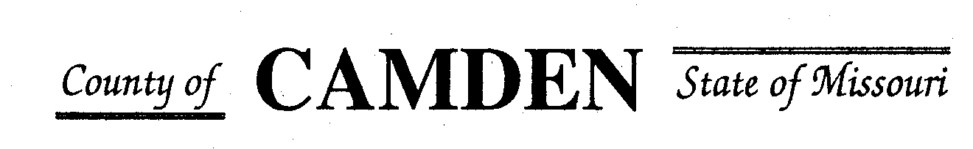

**SENIOR CITIZENS’ SERVICES FUND BOARD**

**Meeting Agenda**

**PLACE: Camden County Court House**

**DATE: September 19, 2024 TIME: 1:00 pm**

* **CALL TO ORDER Cell Phones on silent or turned off Please /Pledge**
* **ROLL CALL – Board Members ~**
* **ROLL CALL OF ATTENDEES~** *Signature sheet, must sign in*
* **STATEMENTS FROM THE PUBLIC (Limited to 3 minutes per Agency or attendee with a maximum of 20 minutes total.)**

* **ADOPTION OF AGENDA.**  Approved
* **APPROVAL OF PREVIOUS MINUTES ~** Approved
* **TREASURER’S REPORTS Funds Available Checking $** CD $
  + - **Checks Received**  **2024 Camden County Tax Funds Received**
    - January $10.89 and $644,386.96
    - February $23,564.27
    - March $20,746.95 and $12,754.08
    - April $10,100.02
    - May $9,283.64
    - June $5,678.69
    - July
    - August
    - September
    - October
    - November
    - December $138,828.95
      * **All checks** electronically **deposited are verified by placing verified next to the amount**
  1. **Outstanding Checks** None
* **OLD BUSINESS**
  + 1. Proforma ~ Submitted to County Clerk Date: 7/19/2024
    2. Osage Beach Senior Center Accountability form updated (sent through 3/24 only)
    3. Aging Best Food and Cost vs Money centers are paying for services if operate independently of Aging Best
* **NEW BUSINESS**
  + **Request for additional Funds**
    - Share the Harvest Voucher
    - Stoutland?
    - Camden County Senior Center

**Motion to Adjourn:**

**NEXT MEETING:** October 17, 2024 @ 1pm Camden County Court House **You or an AUTHORIZED REP MUST BE PRESENT TO PICK UP CHECK OR The Check Will be returned to general fund for disbursement in September.**

**REMINDER Website**: <https://camdencountyseniorservicesfund.com/> to complete RFP for 2024. For all information Regarding Camden County Senior Services Fund. **Secretary email:** [CamdensrBoardSEC@outlook.com](mailto:CamdensrBoardSEC@outlook.com)