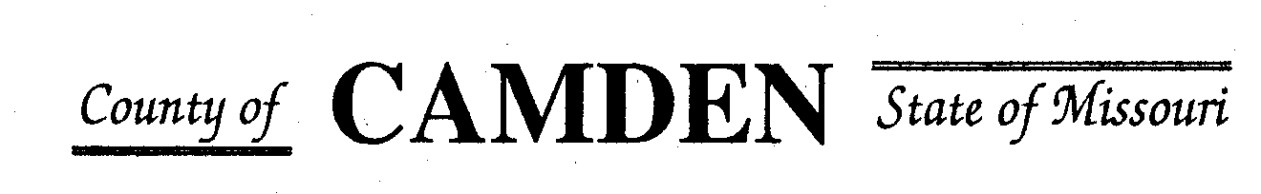

**SENIOR CITIZENS’ SERVICES FUND BOARD**

**AGENDA**

**PLACE: Camden County Court House 3rd floor**

**DATE:  November 18, 2021**

**TIME:  1:00 pm**

* **CALL TO ORDER /Pledge**
* **ROLL CALL – Board Members ~**
* **ROLL CALL OF ATTENDEES~ See Sign in Sheet**
* **ADOPTION OF AGENDA.**
* **APPROVAL OF PREVIOUS MINUTES ~**
* **TREASURER’S REPORTS  Current**
* **OLD BUSINESS**

REMINDER

* + 1. **Website**: <https://camdencountyseniorservicesfund.com/> to complete RFP for 2022. We will try this if you have problems Stephanie can email you the RFP hard Copy
    2. **New Secretary email:** [CamdensrBoardSEC@outlook.com](mailto:CamdensrBoardSEC@outlook.com)
    3. Review of entities Reports for accountability and changes prior to posting on website changes. Posted to Website
* **NEW BUSINESS**
  + 1. Closed Meeting Request to discuss Westlakes Aquatic Center use of funding
    2. RFP’s received roll call:
* **STATEMENTS FROM THE PUBLIC (Limited to 3 minutes per Agency     or attendee with a maximum of 20 minutes total.)**
* **Motion to Adjourn**

**NEXT MEETING:** December 9th, 2021 1pm Camden County Court House 3rd Floor