+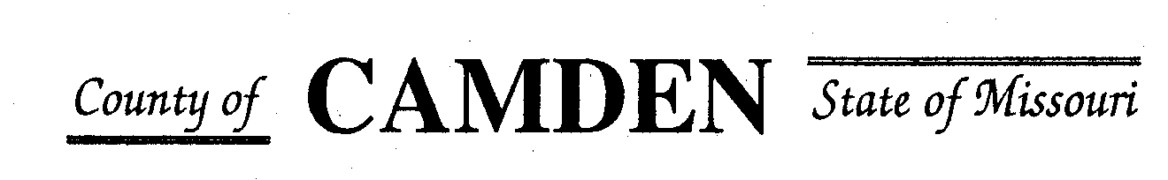

**SENIOR CITIZENS’ SERVICES FUND BOARD**

**Agenda**

**PLACE: Camden County Court House**

**DATE:  December 14, 2023 TIME: 1:00 pm**

* **CALL TO ORDER Cell Phones on silent or turned off Please /Pledge**
* **ROLL CALL – Board Members ~**
* **ROLL CALL OF ATTENDEES~** *Signature sheet, must sign in*
* **STATEMENTS FROM THE PUBLIC (Limited to 3 minutes per Agency or attendee with a maximum of 20 minutes total.)**

**Board Meeting closed to public comments**

* **ADOPTION OF AGENDA.**
* **APPROVAL OF PREVIOUS MINUTES ~**
* **TREASURER’S REPORTS previous bal $400,000 CD Matures in Jan 16, 2024** Funds Available see treasure report $55,017.75 Contingency $16,620.43
  + - **Checks Received**  **2023 Camden County Tax Funds Received**
    - January $581,656.03 verified against bank statement
    - February $36,011.41 verified against bank statement
    - March $11,981.12 verified against bank statement
    - April $10,584.99
    - May $6,158.23 verified against bank statement
    - June $5345.05 confirmed amounts off from Treasurer report to deposit Verified
    - July $5727.97 confirmed amounts off from Treasurer report to deposit Verified
    - Aug $4648.20 verified against bank statement $15,123.81 verified to deposit
    - Sept $4480.20 Verified against bank statement
    - October $0.00 verified
    - November $2736.22 + $2900.74
    - December

**All checks electronically deposited are verified by placing verified next to the amount**

* 1. **Outstanding Checks**
* **OLD BUSINESS**
  + 1. Follow up from Jeff Greene and insurance update to board members
    2. RFP Funding Approved
       - Warren Senior Center Approved for $13400.00
       - Macks Creek Approved for $83000.00
       - Camden County Health Department Approved $16500 for distribution fund the total amount
* **NEW BUSINESS**
  + Update your contact information on sheet and identify who is able to accept check if funding is approved.

1. RFP review and questions to applicants only. **No side conversations please.** We will get through all we have time for and continue the conversations in December and January.
   1. Westside Fitness Center pending follow up of number of Camden County vs Morgan County seniors. Insurance and paid over 60 participants.
   2. Heart to Heart Center for Women’s Ministries no rep
   3. Faith Bridge. Mobile Food Pantry Pay fuel, licensing and taxes. Non profit. Figure out the numbers and get correct and will move to 2
   4. Stoutland
   5. Share the Harvest Voucher
   6. Share the Harvest Food Pantry
   7. Oats
   8. Osage Beach
   9. Camdenton Senior Center
   10. CADV (January)
   11. West Lakes Aquatics
   12. Westside Senior Center
   13. Senior Activity Center
   14. Medical Missions
   15. Four Seasons

**Motion to Adjourn:**

**NEXT MEETING:** January 18, 2024 @ 1pm Camden County Court House

**REMINDER Website**: <https://camdencountyseniorservicesfund.com/> to complete RFP for 2024. For all information Regarding Camden County Senior Services Fund. **Secretary email:** [CamdensrBoardSEC@outlook.com](mailto:CamdensrBoardSEC@outlook.com)