+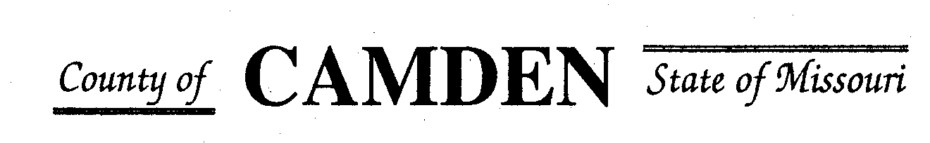

**SENIOR CITIZENS’ SERVICES FUND BOARD**

**Agenda**

**PLACE: Camden County Court House**

**DATE:  October 19, 2023 TIME: 1:00 pm**

* **CALL TO ORDER /Pledge**
* **ROLL CALL – Board Members ~**
* **ROLL CALL OF ATTENDEES~** *Signature sheet, must sign in*
* **ADOPTION OF AGENDA.**
* **APPROVAL OF PREVIOUS MINUTES ~**
* **TREASURER’S REPORTS previous bal $** Funds Available $
  + - **Checks Received**  **2023 Camden County Tax Funds Received**
    - January $581,656.03 verified against bank statement
    - February $36,011.41 verified against bank statement
    - March $11,981.12 verified against bank statement April $10,584.99
    - May $6,158.23 verified against bank statement
    - June $5727.97 needs confirmed amounts off from Treasurer report to deposit
    - July $4647.20 needs confirmed amounts off from Treasurer report to deposit
    - Aug $4480.20 verified against bank statement
    - Sept
    - October
    - November
    - December
    - All checks electronically deposited are verified by placing verified next to the amount
  1. **Outstanding Checks** See treasurer report.
* **OLD BUSINESS**

1. **Accountability Reports due 10/15/23:**

**NEW BUSINESS**

1. **RFP open and due 11/10/2023-Review Submission process**
2. **Review Insurance through County update?**

* **STATEMENTS FROM THE PUBLIC (Limited to 3 minutes per Agency or attendee with a maximum of 20 minutes total.)**
  + Heal center Lunch an learn noon to 1pm also on face book live Elizabeth Barret LAC. Next one is Oct 20th. Cover different topics related to health eastern medicine. Hormonal balance tomorrow**. Flyers, Website and Facebook to notify the community. Food in Laurie. 304 North mainstreet Laurie**
  + Mike Key Richland Sr Service. Starting to see increase in price with the same amount of people but it’s costing 15% more.
* **Motion to Adjourn**  2:00pm Approved

**NEXT MEETING:** September 21, 2023 @ 1pm Camden County Court House

**REMINDER**

* + 1. **Website**: <https://camdencountyseniorservicesfund.com/> to complete RFP for 2022. For all information Regarding Camden County Senior Services Fund.
    2. **New Secretary email:** [CamdensrBoardSEC@outlook.com](mailto:CamdensrBoardSEC@outlook.com)