+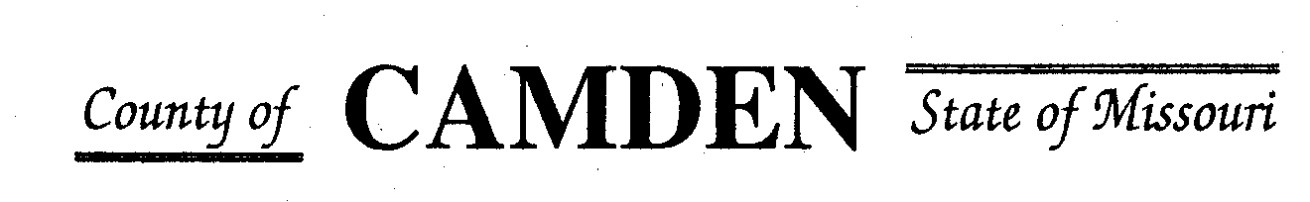

**SENIOR CITIZENS’ SERVICES FUND BOARD**

**Meeting Minutes**

**PLACE: Camden County Court House**

**DATE: July 18, 2024 TIME: 1:00 pm**

* **CALL TO ORDER Cell Phones on silent or turned off Please /Pledge**
* **ROLL CALL – Board Members ~** James Powell. Steph Krehbiel, Jim Rogers, David Curchy, Marie Brown, Janel Bednara, Carolyn Davinroy
* **ROLL CALL OF ATTENDEES~** *Signature sheet, must sign in*
* **STATEMENTS FROM THE PUBLIC (Limited to 3 minutes per Agency or attendee with a maximum of 20 minutes total.)**

* **ADOPTION OF AGENDA.**  Approved
* **APPROVAL OF PREVIOUS MINUTES ~** Approved
* **TREASURER’S REPORTS $ 944,401.69** Funds Available added to certificate $15,939.01 for the period from Jan. 26 to June 24 Sitting at about $105 K in extra funding Will place 375K in CD to run through December or January
  + - **Checks Received**  **2024 Camden County Tax Funds Received**
    - January $10.89 and $644,386.96
    - February $23,564.27
    - March $20,746.95 and $12,754.08
    - April $10,100.02
    - May $9,283.64
    - June $5,678.69
    - July
    - August
    - September
    - October
    - November
    - December $138,828.95
      * **All checks** electronically **deposited are verified by placing verified next to the amount**
  1. **Outstanding Checks** None
* **OLD BUSINESS**
* **NEW BUSINESS**
  1. Proforma
  2. Check Disbursements for approved RFP
     + - Warren Senior Center Approved for $13400.00 Disbursed $6700.00
       - Macks Creek Approved for $83000.00 Disbursed $41,500.00
       - Camden County Health Department Approved $16500 for distribution fund the total amount $33,500.00 Took $5000.00 for July
       - Westside Fitness Center $24K Monthly Reporting Disbursed $12,000.00
       - Faith Bridge $6700.00 Monthly Reporting Disbursed $3,350
       - Stoutland $67,000.00 left aging best no funding from Aging Best
       - Share the Harvest Voucher $100,000.00 w/relook July
       - Share the Harvest Food Pantry $60,000.00
       - Oats $75,000.00
       - Osage Beach $85000.00
       - Heal Center $15,500.00
       - Westside Senior Center $40K
       - Camdenton Senior Center $100,000.
       - Medical Missions $30,000.00 relook July
       - Four Seasons $36,500.00 relook July
       - Senior Activity Center $10,000
       - Heart to Heart Center for Women’s Ministries $1,000.00 with monthly reporting of where funds are used.
       - CADV (Jan) Start Quarterly Reporting $18,000.00

**Motion to Adjourn:**

**NEXT MEETING:** September 19, 2024 @ 1pm Camden County Court House **You or an AUTHORIZED REP MUST BE PRESENT TO PICK UP CHECK OR The Check Will be returned to general fund for disbursement in September.**

**REMINDER Website**: <https://camdencountyseniorservicesfund.com/> to complete RFP for 2024. For all information Regarding Camden County Senior Services Fund. **Secretary email:** [CamdensrBoardSEC@outlook.com](mailto:CamdensrBoardSEC@outlook.com)