+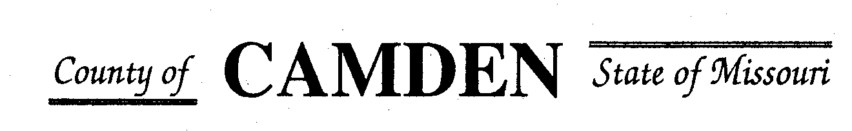

**SENIOR CITIZENS’ SERVICES FUND BOARD**

**Meeting Minutes**

**PLACE: Camden County Court House**

**DATE: January 18th, 2024 TIME: 1:00 pm**

* **CALL TO ORDER Cell Phones on silent or turned off Please /Pledge**
* **ROLL CALL – Board Members ~** Jim Rogers, Carolyn Davinroy, James Powell, Marie Brown, David Curchy, Stephanie Krehbiel
* **ROLL CALL OF ATTENDEES~** *Signature sheet, must sign in*
* **STATEMENTS FROM THE PUBLIC (Limited to 3 minutes per Agency or attendee with a maximum of 20 minutes total.)** NONE

**Board Meeting closed to public comments**

* **ADOPTION OF AGENDA.**  Amended Agenda: Approved
* **APPROVAL OF PREVIOUS MINUTES ~** Approved
* **TREASURER’S REPORTS previous bal $400,000 CD Matures in Jan** Funds Available Year End Balance $209,380.44 with CD #400,000.00 plus interest $12,262.89
* 4625.52 **expenses for the year**
* Recommend put all $50K in another CD in February if approved in Feb for a 5 month CD @5%. Approved
* Surety Bond Received and Bill paid $735.42
  + - **Checks Received**  **2023 Camden County Tax Funds Received**
    - January $581,656.03 verified against bank statement
    - February $36,011.41 verified against bank statement
    - March $11,981.12 verified against bank statement
    - April $10,584.99
    - May $6,158.23 verified against bank statement
    - June $5345.05 confirmed amounts off from Treasurer report to deposit Verified
    - July $5727.97 confirmed amounts off from Treasurer report to deposit Verified
    - Aug $4648.20 verified against bank statement $15,123.81 verified to deposit
    - Sept $4480.20 Verified against bank statement
    - October $0.00 verified
    - November $2736.22 + $2900.74 verified
    - December $138,636.54 verified
      * Kendra needs to update deposit reconciliation of 12/29/23 for $192.41

**All checks electronically deposited are verified by placing verified next to the amount**

* 1. **Outstanding Checks none**
* **OLD BUSINESS**
  + 1. Follow up from Jeff Greene and Bond insurance update to board members, 503c and EIN# still not able to get a hold of him. Writing check today to MO Rural service for insurance for $1920.00
    2. RFP Funding Approved If funding was approved in prior months, you are not required to come to the board meeting but are welcome as always to attend. Reports due to in February for new recipients of RFP funding even with no funds received at this time.
       - Warren Senior Center Approved for $13400.00
       - Macks Creek Approved for $83000.00
       - Camden County Health Department Approved $16500 for distribution fund the total amount $33,500.00
       - Westside Fitness Center $24K Monthly Reporting
       - Faith Bridge $6700.00 Monthly Reporting
       - Stoutland $67,000.00 left aging best no funding from Aging Best
       - Macks Creek $83,000.00
       - Share the Harvest Voucher $100,000.00 w/relook July
       - Share the Harvest Food Pantry $60,000.00
       - Oats $75,000.00
       - Osage Beach $85000.00
       - Heal Center $15,500.00
       - Westside Senior Center $40K
       - Camdenton Senior Center $100,000.
       - Medical Missions $30,000.00 relook July
       - Four Seasons $36,500.00 relook July
       - Senior Activity Center $10,000
* **NEW BUSINESS**
* Set spending limit for secretary for office supplies per month. $200.00
* RFP review and questions to applicants only. **No side conversations please.** We will get through all we have time for and continue the conversations in February.
  + Heart to Heart Center for Women’s Ministries no rep Nov/Dec must be present in Jan or RFP consideration will be withdrawn 1,000.00
  + CADV (Jan) Start Quarterly Reporting $18,000.00
  + West Lakes Aquatics $

**Motion to Adjourn: 2:45pm Approved**

**NEXT MEETING:** February 15, 2024 @ 1pm Camden County Court House **You or an AUTHORIZED REP MUST BE PRESENT TO PICK UP CHECK OR The Check Will be returned to general fund for disbursement in July.**

**REMINDER Website**: <https://camdencountyseniorservicesfund.com/> to complete RFP for 2024. For all information Regarding Camden County Senior Services Fund. **Secretary email:** [CamdensrBoardSEC@outlook.com](mailto:CamdensrBoardSEC@outlook.com)