+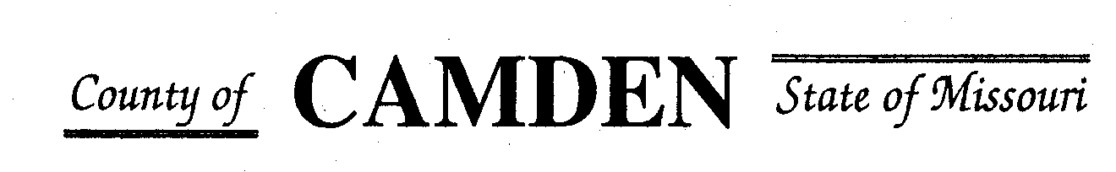

**SENIOR CITIZENS’ SERVICES FUND BOARD**

**Meeting Minutes**

**PLACE: Camden County Court House**

**DATE; October 17, 2024 TIME: 1:00 p.m.**

* **CALL TO ORDER Cell Phones on silent or turned off Please /Pledge**
* **ROLL CALL – Board Members ~** Jim Rogers, Marie Brown, Janel Bednara, Carolyn Davinroy
* **ROLL CALL OF ATTENDEES~** *Signature sheet, must sign in*
* **STATEMENTS FROM THE PUBLIC (Limited to 3 minutes per Agency or attendee with a maximum of 20 minutes total.)**
* **ADOPTION OF AGENDA.**  Motion to add payment for work completed to Stephanie Krehbiel. Approved Motion passed
* **APPROVAL OF PREVIOUS MINUTES ~** Approved Motion passed
* **TREASURER’S REPORTS Funds Available Checking $208,058.13** CD $350,000.00
  + - **Checks Received**  **2024 Camden County Tax Funds Received**
    - January $10.89 and $644,386.96 Verified
    - February $23,564.27 Verified
    - March $20,746.95 and $12,754.08 Verified
    - April $10,100.02 Verified
    - May $9,283.64 Verified
    - June $5,678.69 Verified
    - July $4,764.38 Verified
    - August $5,958.96 Verified
    - September $5,217.45 Verified
    - October
    - November
    - December $138,828.95 (12/2023) Verified
      * **All checks** electronically **deposited are verified by placing verified next to the amount**

**Outstanding Checks** Westlakes 22,500.00

* **OLD BUSINESS**

1. Report on Aging Best ZOOM Meeting
2. Working with Jeff Green with the Aging Best issue.

* **NEW BUSINESS**

1. RFPs on Website, emailed, or mailed by November 8, 2024
2. **Motion** to pay Stephanie Krehbiel for 37 hours of work totaling 555.00. **Second. Passed.**
3. **Motion** to no longer send Board mail to Board Members’ home. But to secure a P.O. Box at Sunrise Beach ($142.00 per year). **Second. Passed.**
4. Motion to give Jim Rogers authorization to contact Central Bank about the new address and to secure new checks. ($25.00 for 80 checks)-Checking for free checks. **Second. Passed.**

**Motion to Adjourn: 1:25 p.m. NEXT MEETING: November 21**, 2024 @ 1 p.m. Camden County Court House. **Second. Passed.**

**You or an AUTHORIZED REP MUST BE PRESENT TO PICK UP CHECK OR The Check Will be returned to general fund for disbursement in September.**

**REMINDER Website**: <https://camdencountyseniorservicesfund.com/> to complete RFP for 2024. For all information Regarding Camden County Senior Services Fund. **Secretary email:** [CamdensrBoardSEC@outlook.com](mailto:CamdensrBoardSEC@outlook.com)