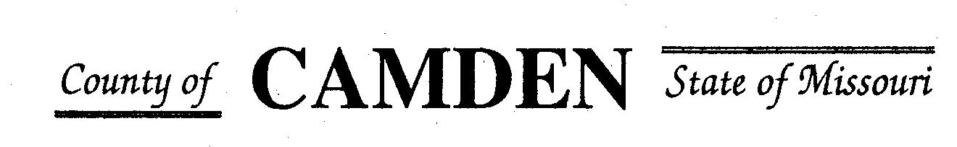

PUBLIC NOTICE

SENIOR CITIZENS’ SERVICES FUND BOARD

MONTHLY MEETING SCHEDULE

1/1/2025 – 12/31/2025

THE CAMDEN COUNTY SENIOR CITIZENS’ SERVICES FUND BOARD WILL MEET AT 1:00 PM ON THE DATES BELOW at the Camden County Court House

January 16, 2025 September 18, 2025

February 20, 2025 October 16, 2025

March 20, 2025 TBD November 20, 2025

July 17, 2025 December 11, 2025

MEETINGS ARE REGULARLY HELD ON THE 3RD THURSDAY OF EACH DESIGNATED MONTH, (EXCEPT 2nd THURSDAY IN DECEMBER) unless otherwise noted 3rd floor Camden Co. Court House.

THE PUBLIC IS WELCOME.